**MODUL PRAKTIKUM**

**SISTEM PENDUKUNG KEPUTUSAN**



**NAMA : ....................................................**

**NPM : ....................................................**

**KELAS : ....................................................**

**PROGRAM STUDI TEKNIK INFORMATIKA**

**FAKULTAS TEKNIK**

**UNIVERSITAS MUHAMMADIYAH MALUKU UTARA**

**UMMU TERNATE**

**2014**

**Program Sederhana Sistem Pendukung Keputusan Promosi Jabatan Menggunakan Model Pencocokan Profil**

1. **Pembuatan Database**

* Daftar Susunan Tabel

Karyawan

|  |  |  |
| --- | --- | --- |
| **Field** | **DataType** | **Field Size** |
| KodeKar | Text | 5 |
| Karyawan | Text | 30 |

Aspek

|  |  |  |
| --- | --- | --- |
| **Field** | **DataType** | **Field Size** |
| KodeAsp | Text | 5 |
| Aspek | Text | 60 |
| Presentase | Number | Single |
| PersenCF | Number | Single |
| PersenSF | Number | Single |

SubAspek

|  |  |  |
| --- | --- | --- |
| **Field** | **DataType** | **Field Size** |
| KodeSub | Text | 5 |
| Aspek | Text | 60 |
| PJ | Number | Long Integer |
| Ket | Text | 5 |

RelasiKar

|  |  |  |
| --- | --- | --- |
| **Field** | **DataType** | **Field Size** |
| KodeKar | Text | 5 |
| KodeAsp | Text | 5 |
| KodeSub | Text | 5 |
| Nilai | Number | Long Integer |
| GAP | Number | Long Integer |
| KonvGAP | Number | Single |
| NCF | Number | Single |
| NSF | Number | Single |
| Ni | Number | Single |
| Rank | Number | Single |
| Ket | Text | 3 |

RelasiAsp

|  |  |  |
| --- | --- | --- |
| **Field** | **DataType** | **Field Size** |
| KodeSub | Text | 5 |
| KodeAsp | Text | 5 |

GAP

|  |  |  |
| --- | --- | --- |
| **Field** | **DataType** | **Field Size** |
| ID | Number | Long Integer |
| Skor | Number | Single |

1. **Relasi Tabel**

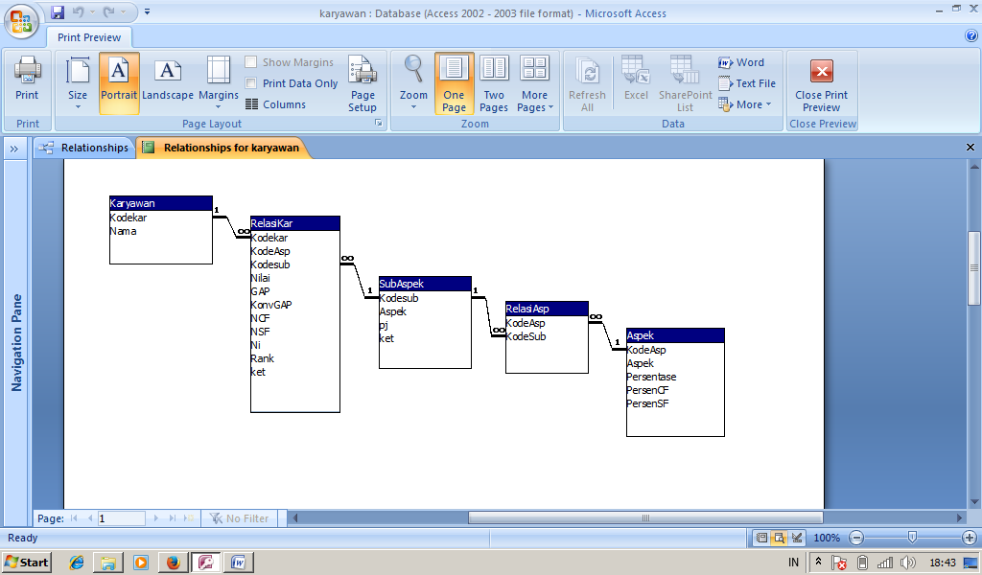

1. **Perancangan Program**

* **Module**

Public conn As New ADODB.Connection

Public rskar As New ADODB.Recordset

Public rsskor As New ADODB.Recordset

Public rsgap As New ADODB.Recordset

Public rskonv As New ADODB.Recordset

Public rs1 As New ADODB.Recordset

Public rs2 As New ADODB.Recordset

Public str As String

Sub koneksi()

Set conn = New ADODB.Connection

conn.Provider = "microsoft.jet.oledb.4.0"

conn.CursorLocation = adUseClient

conn.Open App.Path & "\karyawan.mdb"

End Sub

|  |  |
| --- | --- |
| **Property** | |
| **Field** | **DataType** |
| Name | Module1 |

* 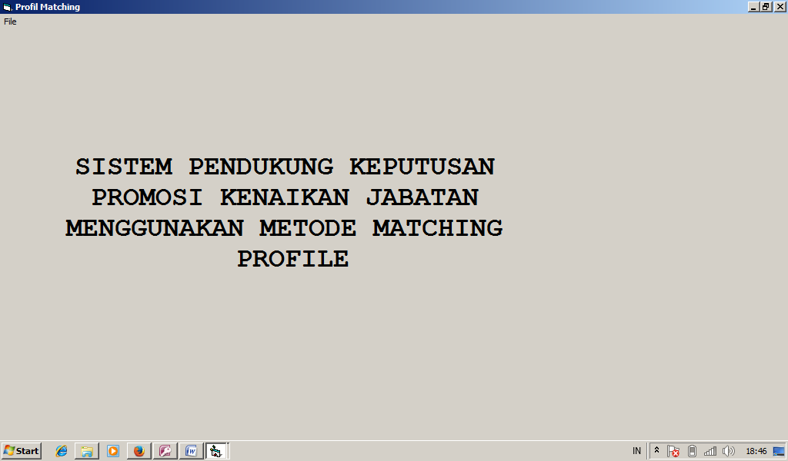**Menu Utama**

|  |  |
| --- | --- |
| **Properti Menu Utama** | |
| Name | frmMenu |
| Caption | Profil Matching |
| WindowsState | Maximized |

* **Menu Editor**

|  |  |
| --- | --- |
| **Properti File** | |
| Name | MnFile |
| Caption | File |
| **Properti Data Penilaian** | |
| Name | mnPenilaian |
| Caption | Data Penilaian |
| **Properti Skoring** | |
| Name | mnskor |
| Caption | Skoring |
| **Properti Keluar** | |
| Name | mnKeluar |
| Caption Keluar |  |

**Baris Kode Menu Utama**

Private Sub Form_Load()

koneksi

End Sub

Private Sub mnKeluar_Click()

End

End Sub

Private Sub mnPenilaian_Click()

frmPenilaian.Show vbModal

End Sub

Private Sub mnskor_Click()

frmSkoring.Show vbModal

End Sub

* **Form Penilaian**

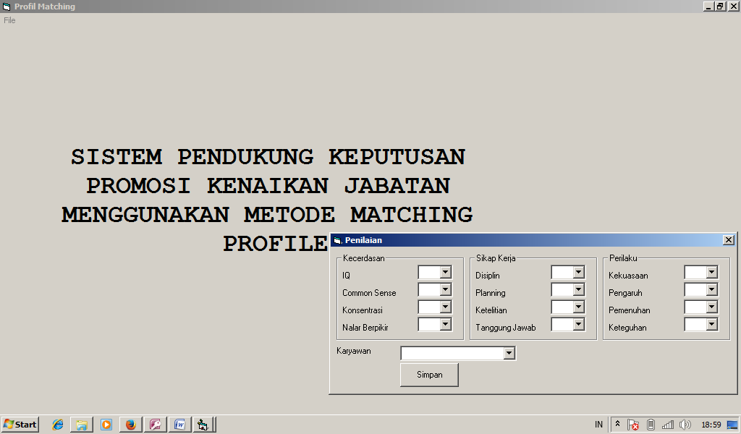

|  |  |
| --- | --- |
| **Properti Kecerdasan** | |
| Name | cmbIQ |
| Caption | IQ |
| Name | cmbComm |
| Caption | Common sense |
| Name | cmbKon |
| Caption | Konsentrasi |
| Name | cmbNalar |
| Caption | Penalaran Berpikir |

|  |  |
| --- | --- |
| **Properti Sikap Kerja** | |
| Name | cmbdisp |
| Caption | Disiplin |
| Name | cmbplan |
| Caption | Planning |
| Name | cmbteliti |
| Caption | Teliti |
| Name | cmbtangg |
| Caption | Tanggung jawab |

|  |  |
| --- | --- |
| **Properti Perilaku** | |
| Name | cmbkuasa |
| Caption | Kekuasaan |
| Name | cmbpengaruh |
| Caption | Pengaruh |
| Name | cmbpenuh |
| Caption | Pemenuhan |
| Name | Cmbteguh |
| Caption | Keteguhan |

|  |  |
| --- | --- |
| **Properti commandbutton** | |
| Name | Cmdsimpan |
| Caption | Simpan |

|  |  |
| --- | --- |
| **Properti karyawan** | |
| Name | CmbKaryawan |
| Caption | karyawan |

|  |  |
| --- | --- |
| **Properti Form Penilaian** | |
| Name | frmPenilaian |
| Caption | Penilaian |
| BorderStyle | Fixed Dialog |
| StartUpPosition | CenterScreen |

Baris Kode Form Penilaian

Sub isicombo()

Dim Control

For Each Control In Me.Controls

If TypeOf Control Is ComboBox Then

Control.Clear

End If

Next Control

For Each Control In Me.Controls

If TypeOf Control Is ComboBox Then

Control.AddItem 1

Control.AddItem 2

Control.AddItem 3

Control.AddItem 4

Control.AddItem 5

End If

Next Control

cmbkaryawan.Clear

str = "select * from karyawan"

Set rskar = conn.Execute(str, adCmdText)

If Not rskar.EOF Then

rskar.MoveFirst

Do Until rskar.EOF

cmbkaryawan.AddItem rskar!kodekar & " " & rskar!Nama

rskar.MoveNext

Loop

End If

rskar.Close

End Sub

Private Sub cmdsimpan_Click()

simpan

End Sub

Private Sub Form_Load()

isicombo

End Sub

Sub simpan()

For Each Control In Me.Controls

If TypeOf Control Is ComboBox Then

If Control.Text = "" Then

MsgBox "Lengkapi Pengisian"

Exit Sub

End If

End If

Next Control

Dim strs As String

Dim r As String

r = Mid(cmbkaryawan.Text, 1, 5)

strs = "select * from relasikar where kodekar = '" & r & "'"

Set rskar = conn.Execute(strs, adCmdText)

If rskar.EOF Then

str = "insert into relasikar (kodekar,kodeasp,kodesub,nilai,ket) values ('" & r & "','A001','K001','" & Val(cmbIQ.Text) & "','CF')"

conn.Execute str, adCmdText

str = "insert into relasikar (kodekar,kodeasp,kodesub,nilai,ket) values ('" & r & "','A001','K002','" & Val(cmbComm.Text) & "','SF')"

conn.Execute str, adCmdText

str = "insert into relasikar (kodekar,kodeasp,kodesub,nilai,ket) values ('" & r & "','A001','K003','" & Val(cmbKon.Text) & "','CF')"

conn.Execute str, adCmdText

str = "insert into relasikar (kodekar,kodeasp,kodesub,nilai,ket) values ('" & r & "','A001','K004','" & Val(cmbnalar.Text) & "','SF')"

conn.Execute str, adCmdText

str = "insert into relasikar (kodekar,kodeasp,kodesub,nilai,ket) values ('" & r & "','A002','L001','" & Val(cmbdisp.Text) & "','CF')"

conn.Execute str, adCmdText

str = "insert into relasikar (kodekar,kodeasp,kodesub,nilai,ket) values ('" & r & "','A002','L002','" & Val(cmbteliti.Text) & "','SF')"

conn.Execute str, adCmdText

str = "insert into relasikar (kodekar,kodeasp,kodesub,nilai,ket) values ('" & r & "','A002','L003','" & Val(cmbplan.Text) & "','CF')"

conn.Execute str, adCmdText

str = "insert into relasikar (kodekar,kodeasp,kodesub,nilai,ket) values ('" & r & "','A002','L004','" & Val(cmbtangg.Text) & "','SF')"

conn.Execute str, adCmdText

str = "insert into relasikar (kodekar,kodeasp,kodesub,nilai,ket) values ('" & r & "','A003','M001','" & Val(cmbkuasa.Text) & "','CF')"

conn.Execute str, adCmdText

str = "insert into relasikar (kodekar,kodeasp,kodesub,nilai,ket) values ('" & r & "','A003','M002','" & Val(cmbpengaruh.Text) & "','SF')"

conn.Execute str, adCmdText

str = "insert into relasikar (kodekar,kodeasp,kodesub,nilai,ket) values ('" & r & "','A003','M003','" & Val(cmbpenuh.Text) & "','CF')"

conn.Execute str, adCmdText

str = "insert into relasikar (kodekar,kodeasp,kodesub,nilai,ket) values ('" & r & "','A003','M004','" & Val(cmbteguh.Text) & "','SF')"

conn.Execute str, adCmdText

MsgBox "Data Tersimpan"

kosong

Else

If MsgBox("Data sudah ada Anda Yakin ingin Menimpa data?", vbYesNo + vbQuestion, "Konfirmasi") = vbYes Then

str = "delete * from relasikar where kodekar = '" & r & "'"

conn.Execute str, adCmdText

str = "insert into relasikar (kodekar,kodeasp,kodesub,nilai,ket) values ('" & r & "','A001','K001','" & Val(cmbIQ.Text) & "','CF')"

conn.Execute str, adCmdText

str = "insert into relasikar (kodekar,kodeasp,kodesub,nilai,ket) values ('" & r & "','A001','K002','" & Val(cmbComm.Text) & "','SF')"

conn.Execute str, adCmdText

str = "insert into relasikar (kodekar,kodeasp,kodesub,nilai,ket) values ('" & r & "','A001','K003','" & Val(cmbKon.Text) & "','CF')"

conn.Execute str, adCmdText

str = "insert into relasikar (kodekar,kodeasp,kodesub,nilai,ket) values ('" & r & "','A001','K004','" & Val(cmbnalar.Text) & "','SF')"

conn.Execute str, adCmdText

str = "insert into relasikar (kodekar,kodeasp,kodesub,nilai,ket) values ('" & r & "','A002','L001','" & Val(cmbdisp.Text) & "','CF')"

conn.Execute str, adCmdText

str = "insert into relasikar (kodekar,kodeasp,kodesub,nilai,ket) values ('" & r & "','A002','L002','" & Val(cmbteliti.Text) & "','SF')"

conn.Execute str, adCmdText

str = "insert into relasikar (kodekar,kodeasp,kodesub,nilai,ket) values ('" & r & "','A002','L003','" & Val(cmbplan.Text) & "','CF')"

conn.Execute str, adCmdText

str = "insert into relasikar (kodekar,kodeasp,kodesub,nilai,ket) values ('" & r & "','A002','L004','" & Val(cmbtangg.Text) & "','SF')"

conn.Execute str, adCmdText

str = "insert into relasikar (kodekar,kodeasp,kodesub,nilai,ket) values ('" & r & "','A003','M001','" & Val(cmbkuasa.Text) & "','CF')"

conn.Execute str, adCmdText

str = "insert into relasikar (kodekar,kodeasp,kodesub,nilai,ket) values ('" & r & "','A003','M002','" & Val(cmbpengaruh.Text) & "','SF')"

conn.Execute str, adCmdText

str = "insert into relasikar (kodekar,kodeasp,kodesub,nilai,ket) values ('" & r & "','A003','M003','" & Val(cmbpenuh.Text) & "','CF')"

conn.Execute str, adCmdText

str = "insert into relasikar (kodekar,kodeasp,kodesub,nilai,ket) values ('" & r & "','A003','M004','" & Val(cmbteguh.Text) & "','SF')"

conn.Execute str, adCmdText

MsgBox "Data diupdate"

kosong

End If

End If

End Sub

Sub kosong()

cmbIQ.Text = ""

cmbComm.Text = ""

cmbKon.Text = ""

cmbnalar.Text = ""

cmbdisp.Text = ""

cmbplan.Text = ""

cmbteliti.Text = ""

cmbtangg.Text = ""

cmbkuasa.Text = ""

cmbpengaruh.Text = ""

cmbpenuh = ""

cmbteguh.Text = ""

cmbkaryawan.Text = ""

End Sub

* **Form Skoring**

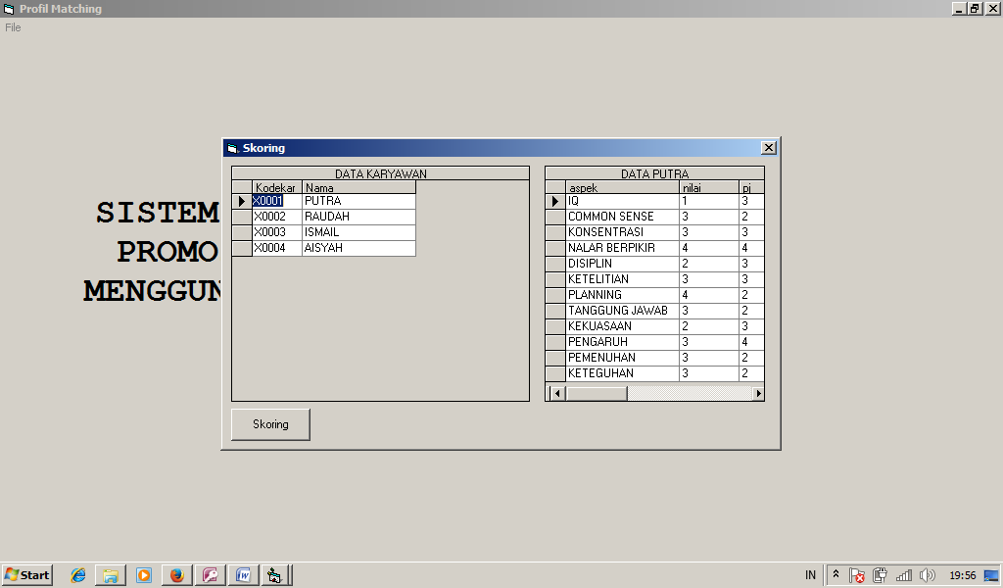

|  |  |
| --- | --- |
| **Properti Form Skoring** | |
| Name | frmSkoring |
| Caption | Skoring |
| BorderStyle | Fixed Dialog |
| StartUpPosition | CenterScreen |

|  |  |
| --- | --- |
| **Properti DataGrid** | |
| Name | DGKar |
| Caption | Data Karyawan |
| Name | DGNilai |
| Caption |  |

|  |  |
| --- | --- |
| **Properti CommandButton** | |
| Name | cmdskor |
| Caption | Skoring |

|  |  |
| --- | --- |
| **Properti Crystal Report** | |
| Name | CR |

**Baris Kode frmSkoring**

Sub refreshdgkar()

str = "select * from karyawan"

Set rskar = conn.Execute(str, adCmdText)

Set DGKar.DataSource = rskar

DGKar.Refresh

End Sub

Private Sub cmdSkor_Click()

gap

konvgap

NCF

NSF

ni_total

ranking

cetak

End Sub

Sub konvgap()

Dim str21, su, ka As String

Dim s As Single

str21 = "select * from relasikar order by kodekar asc"

Set rskonv = conn.Execute(str21, adCmdText)

If Not rskonv.EOF Then

rskonv.MoveFirst

Do Until rskonv.EOF

Dim str2 As String

ka = rskonv!kodekar

su = rskonv!kodesub

s = rskonv!gap

str2 = "select * from GAP where ID = " & s & ""

Set rsgap = conn.Execute(str2, adCmdText)

If Not rsgap.EOF Then

str = "update relasikar set KonvGAP = '" & rsgap!skor & "' where kodesub = '" & su & "' and kodekar = '" & ka & "'"

conn.Execute str, adCmdText

End If

rskonv.MoveNext

Loop

End If

End Sub

Sub gap()

Dim str21, s, su, ka As String

Dim nil As Integer

str21 = "select * from relasikar order by kodekar asc"

Set rskonv = conn.Execute(str21, adCmdText)

If Not rskonv.EOF Then

rskonv.MoveFirst

Do Until rskonv.EOF

Dim str2 As String

ka = rskonv!kodekar

su = rskonv!kodesub

nil = rskonv!nilai

str2 = "select * from Subaspek where Kodesub = '" & su & "'"

Set rsgap = conn.Execute(str2, adCmdText)

If Not rsgap.EOF Then

nil = nil - rsgap!pj

str = "update relasikar set GAP = '" & nil & "' where kodesub = '" & su & "' and kodekar = '" & ka & "'"

conn.Execute str, adCmdText

End If

rskonv.MoveNext

Loop

End If

End Sub

Private Sub DGKar_Click()

Dim r As String

r = Mid(DGKar.Columns(0), 1, 5)

Dim str2 As String

str2 = "select subaspek.aspek,relasikar.nilai,subaspek.pj from relasikar,subaspek where relasikar.kodesub = subaspek.kodesub and relasikar.kodekar = '" & r & "'"

Set rsskor = conn.Execute(str2, adCmdText)

Set DGNilai.DataSource = rsskor

DGNilai.Refresh

DGNilai.Caption = "DATA " & DGKar.Columns(1) & ""

End Sub

Private Sub DGKar_KeyDown(KeyCode As Integer, Shift As Integer)

DGKar_Click

End Sub

Private Sub Form_Activate()

refreshdgkar

DGKar_Click

End Sub

Sub NCF()

Dim str3, str5, str4, kar, asp As String

Dim nc, n1, n2 As Single

str = "select * from karyawan order by kodekar"

Set rsgap = conn.Execute(str, adCmdText)

If Not rsgap.EOF Then

rsgap.MoveFirst

Do Until rsgap.EOF

kar = rsgap!kodekar

str3 = "select * from Aspek order by KodeAsp"

Set rskonv = conn.Execute(str3, adcmtext)

If Not rskonv.EOF Then

rskonv.MoveFirst

Do Until rskonv.EOF

asp = rskonv!kodeasp

str4 = "select KonvGap from relasikar where kodekar = '" & kar & "' and kodeasp = '" & asp & "' and ket = 'CF'"

Set rs1 = conn.Execute(str4, adCmdText)

If Not rs1.EOF Then

rs1.MoveFirst

n1 = 0

n2 = 0

Do Until rs1.EOF

If n1 = 0 Then

n1 = rs1!konvgap

rs1.MoveNext

End If

If n2 = 0 And n1 <> 0 Then

n2 = rs1!konvgap

nc = (n1 + n2) / 2

str5 = "update relasikar set NCF = '" & nc & "' where kodekar = '" & kar & "' and kodeasp = '" & asp & "'"

conn.Execute str5, adCmdText

End If

rs1.MoveNext

Loop

End If

rskonv.MoveNext

Loop

End If

rsgap.MoveNext

Loop

End If

End Sub

Sub NSF()

Dim str3, str5, str4, kar, asp As String

Dim nc, n1, n2 As Single

str = "select * from karyawan order by kodekar"

Set rsgap = conn.Execute(str, adCmdText)

If Not rsgap.EOF Then

rsgap.MoveFirst

Do Until rsgap.EOF

kar = rsgap!kodekar

str3 = "select * from Aspek order by KodeAsp"

Set rskonv = conn.Execute(str3, adcmtext)

If Not rskonv.EOF Then

rskonv.MoveFirst

Do Until rskonv.EOF

asp = rskonv!kodeasp

str4 = "select KonvGap from relasikar where kodekar = '" & kar & "' and kodeasp = '" & asp & "' and ket = 'SF'"

Set rs1 = conn.Execute(str4, adCmdText)

If Not rs1.EOF Then

rs1.MoveFirst

n1 = 0

n2 = 0

Do Until rs1.EOF

If n1 = 0 Then

n1 = rs1!konvgap

rs1.MoveNext

End If

If n2 = 0 And n1 <> 0 Then

n2 = rs1!konvgap

nc = (n1 + n2) / 2

str5 = "update relasikar set NSF = '" & nc & "' where kodekar = '" & kar & "' and kodeasp = '" & asp & "'"

conn.Execute str5, adCmdText

End If

rs1.MoveNext

Loop

End If

rskonv.MoveNext

Loop

End If

rsgap.MoveNext

Loop

End If

End Sub

Sub ni_total()

Dim str3, str5, str4, kar, asp As String

Dim nc, n1, n2, perCF, perSF As Single

str = "select * from karyawan order by kodekar"

Set rsgap = conn.Execute(str, adCmdText)

If Not rsgap.EOF Then

rsgap.MoveFirst

Do Until rsgap.EOF

kar = rsgap!kodekar

str3 = "select * from Aspek order by KodeAsp"

Set rskonv = conn.Execute(str3, adcmtext)

If Not rskonv.EOF Then

rskonv.MoveFirst

Do Until rskonv.EOF

perCF = rskonv!PersenCF

perSF = rskonv!PersenSF

asp = rskonv!kodeasp

str4 = "select NCF,NSF from relasikar where kodekar = '" & kar & "' and kodeasp = '" & asp & "'"

Set rs1 = conn.Execute(str4, adCmdText)

If Not rs1.EOF Then

n1 = rs1!NCF

n2 = rs1!NSF

nc = (n1 * perCF) + (n2 * perSF)

str5 = "update relasikar set Ni = '" & nc & "' where kodekar = '" & kar & "' and kodeasp = '" & asp & "'"

conn.Execute str5, adCmdText

End If

rskonv.MoveNext

Loop

End If

rsgap.MoveNext

Loop

End If

End Sub

Sub ranking()

Dim str3, str5, str4, kar, asp As String

Dim nc, n1, n2, per1, cerd, sik, peri, has As Single

str = "select * from karyawan order by kodekar"

Set rsgap = conn.Execute(str, adCmdText)

If Not rsgap.EOF Then

rsgap.MoveFirst

Do Until rsgap.EOF

kar = rsgap!kodekar

str3 = "select * from Aspek order by KodeAsp"

Set rskonv = conn.Execute(str3, adcmtext)

cerd = 0

sik = 0

peri = 0

If Not rskonv.EOF Then

rskonv.MoveFirst

Do Until rskonv.EOF

asp = rskonv!kodeasp

per1 = rskonv!Persentase

str4 = "select Ni from relasikar where kodekar = '" & kar & "' and kodeasp = '" & asp & "'"

Set rs1 = conn.Execute(str4, adCmdText)

nc = per1 * rs1!Ni

If cerd = 0 And peri = 0 And sik = 0 Then

cerd = nc

ElseIf cerd <> 0 And peri = 0 And sik = 0 Then

peri = nc

ElseIf cerd <> 0 And peri <> 0 And sik = 0 Then

sik = nc

has = cerd + peri + sik

str5 = "update relasikar set Rank = '" & has & "' where kodekar = '" & kar & "'"

conn.Execute str5, adCmdText

cerd = 0

sik = 0

peri = 0

End If

rskonv.MoveNext

Loop

End If

rsgap.MoveNext

Loop

End If

End Sub

Sub cetak()

str = "select * from relasikar order by rank Desc"

Set rskar = conn.Execute(str, adCmdText)

rskar.Requery

With CR

.Reset

.ReportFileName = App.Path & "\Report1.rpt"

.DataFiles(0) = App.Path & "\karyawan.mdb"

.WindowMinButton = False

.WindowShowCancelBtn = True

.WindowShowCloseBtn = True

.WindowShowPrintBtn = True

.WindowShowPrintSetupBtn = True

.WindowParentHandle = frmMenu.hWnd

.WindowState = crptMaximized

.Action = 1

Me.Visible = False

End With

End Sub